SQL Question Mu Sigma

1. List the month name and number of employees hired in each month and ignore the year factor Note: Two different years but the same month's hired employee count should be summed together to get the total of employees hired in the respective month.

(MONTH NUMBER IS OBTAINED INPLACE OF MONTH NAME ; NOTE: CAN USE MONTHNAME() )

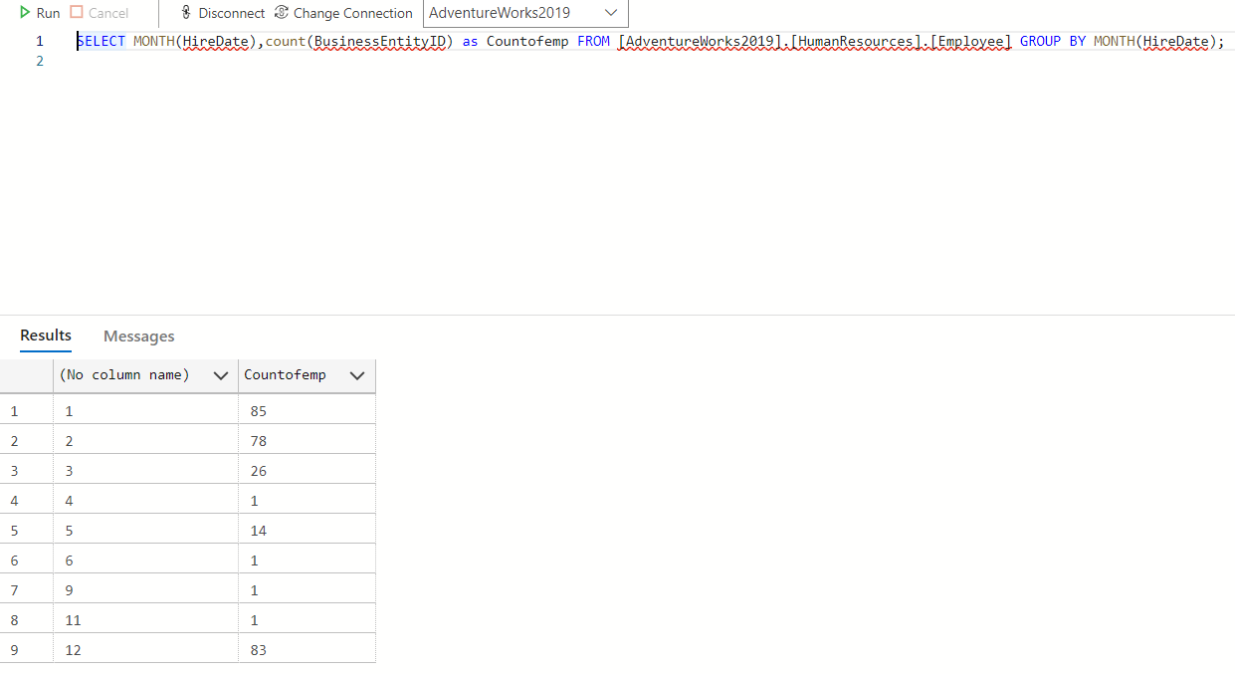

1. Lis t d e p a r t m e n t n a m e, a n d t h e n u m b e r o f e m plo y e e s hir e d in e a c h d e p a r t m e n t y e a r - wis e

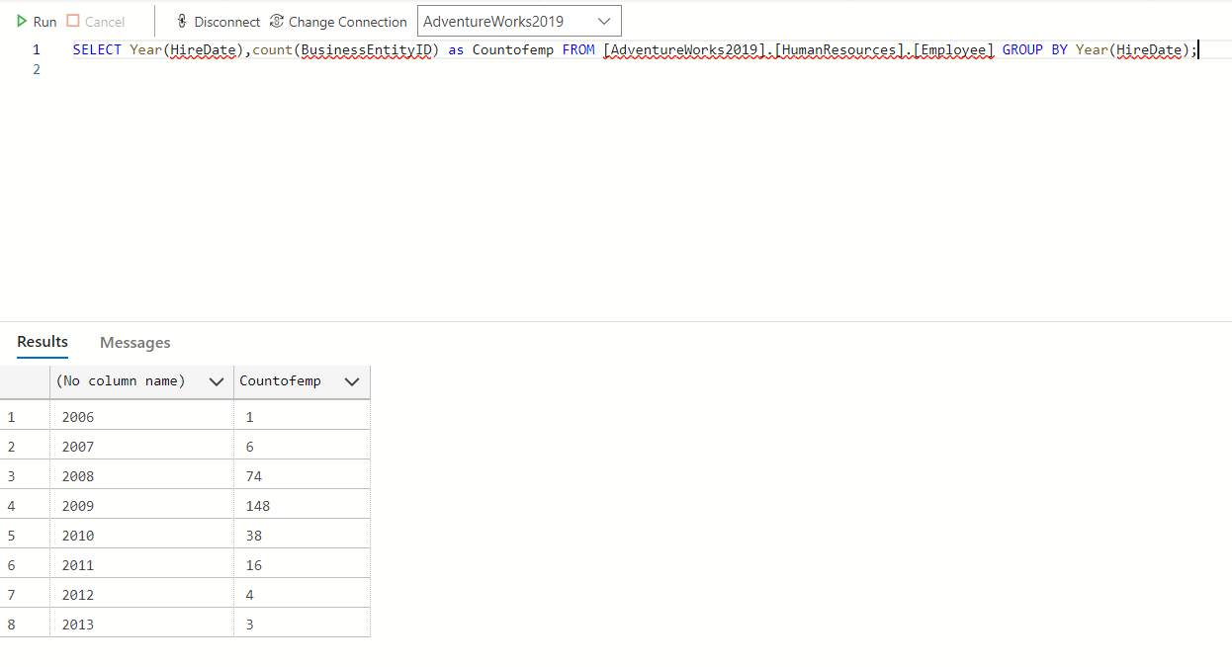

1. List the person and their country region name who is not an employee and their name starts with the character “S”.

